**Ali Asghar**

**P20-0611**

**5A-BSCS**

**Lab 11 Computer Networks**

### Step 1: Subnet the 192.168.100.0/24 network into the appropriate number of subnets.

1. Based on the topology, how many subnets are needed?  
   **5 Four for the LANs, and one for the link between the routers.**

1. How many bits must be borrowed to support the number of subnets in the topology table?  
   **3**

1. How many subnets does this create?  
   **8**

1. How many usable hosts does this create per subnet?  
   **30**  
     
   **Note:** If your answer is less than the 25 hosts required, then you borrowed too many bits.

1. Calculate the binary value for the first five subnets. The first two subnets have been done for you.

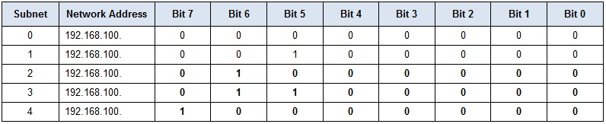

1. Calculate the binary and decimal value of the new subnet mask.

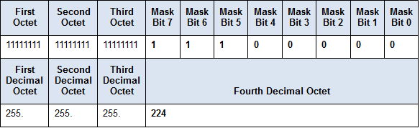

1. Fill in the Subnet Table,listing the decimal value of all available subnets, the first and last usable host address, and the broadcast address. Repeat until all addresses are listed.  
     
   **Note:** You may not need to use all rows.

### Subnet Table

* 1. 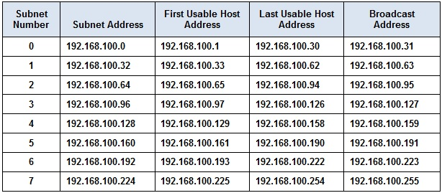

### Step 2: Assign the subnets to the network shown in the topology.

1. Assign Subnet 0 to the LAN connected to the GigabitEthernet 0/0 interface of R1: 192.168.100.0 /27

* 1. Assign Subnet 1 to the LAN connected to the GigabitEthernet 0/1 interface of R1: 192.168.100.32 /27
  2. Assign Subnet 2 to the LAN connected to the GigabitEthernet 0/0 interface of R2: 192.168.100.64 /27
  3. Assign Subnet 3 to the LAN connected to the GigabitEthernet 0/1 interface of R2: 192.168.100.96 /27
  4. Assign Subnet 4 to the WAN link between R1 to R2: 192.168.100.128 /27

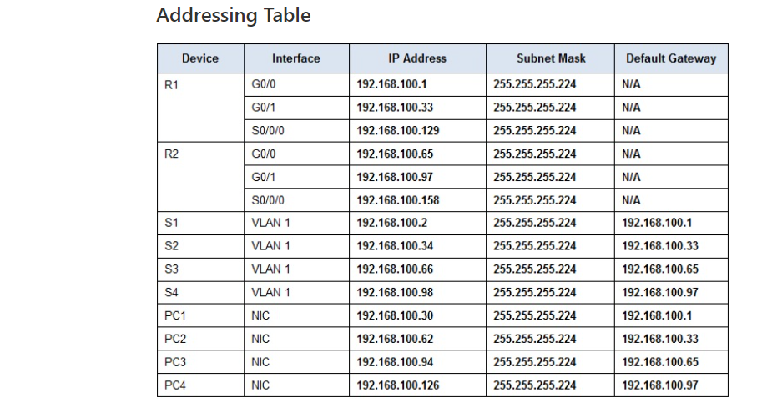

**Topology B:**

Implement Task 4 (Lab 10) in Packet Tracer and Assign IP Addresses to Network

Devices and Verify Connectivity.



#### Step 1: Determine the number of subnets in Network Topology C.

1. How many subnets are there? ___________ 6
2. How many bits should you borrow to create the required number of subnets? _________ 3
3. How many usable host addresses per subnet are in this addressing scheme? ___________ 30
4. What is the new subnet mask in dotted decimal format? _________________________ 255.255.255.224
5. How many subnets are available for future use? _______________ 2

#### Step 2: Record the subnet information.

Fill in the following table with the subnet information:

|  |  |  |  |  |
| --- | --- | --- | --- | --- |
| **Subnet Number** | **Subnet Address** | **First Usable Host Address** | **Last Usable Host Address** | **Broadcast Address** |
| 0 | 192.168.10.0 | 192.168.10.1 | 192.168.10.30 | 192.168.10.31 |
| 1 | 192.168.10.32 | 192.168.10.33 | 192.168.10.62 | 192.168.10.63 |
| 2 | 192.168.10.64 | 192.168.10.65 | 192.168.10.94 | 192.168.10.95 |
| 3 | 192.168.10.96 | 192.168.10.97 | 192.168.10.126 | 192.168.10.127 |
| 4 | 192.168.10.128 | 192.168.10.129 | 192.168.10.158 | 192.168.10.159 |
| 5 | 192.168.10.160 | 192.168.10.161 | 192.168.10.190 | 192.168.10.191 |
| 6 | 192.168.10.192 | 192.168.10.193 | 192.168.10.222 | 192.168.10.223 |
| 7 | 192.168.10.224 | 192.168.10.225 | 192.168.10.254 | 192.168.10.255 |
| 8 |  |  |  |  |
| 9 |  |  |  |  |
| 10 |  |  |  |  |

#### Step 3: Assign addresses to network devices in the subnets.

1. Fill in the following table with IP addresses and subnet masks for the router interfaces:  
   **Answers Note**: These are suggested IP addresses based on using the first 6 subnets from the table above as assigned to each segment.

|  |  |  |  |
| --- | --- | --- | --- |
| **Device** | **Interface** | **IP Address** | **Subnet Mask** |
| R1 | GigabitEthernet 0/1 | 192.168.10.1 | 255.255.255.224 |
|  | Serial 0/0/0 | 192.168.10.33 | 255.255.255.224 |
|  | Serial 0/0/1 | 192.168.10.65 | 255.255.255.224 |
| R2 | GigabitEthernet 0/1 | 192.168.10.97 | 255.255.255.224 |
|  | Serial 0/0/0 | 192.168.10.34 | 255.255.255.224 |
|  | Serial 0/0/1 | 192.168.10.129 | 255.255.255.224 |
| R3 | GigabitEthernet 0/1 | 192.168.10.161 | 255.255.255.224 |
|  | Serial 0/0/0 | 192.168.10.66 | 255.255.255.224 |
|  | Serial 0/0/1 | 192.168.10.130 | 255.255.255.224 |

1. Fill in the following table with the IP addresses and subnet masks for devices in the LAN as displayed in topology.  
   **Answers Note**: These are suggested IP addresses based on using the first 6 subnets from the table above as assigned to each segment.

|  |  |  |  |  |
| --- | --- | --- | --- | --- |
| **Device** | **Interface** | **IP Address** | **Subnet Mask** | **Default Gateway** |
| PC-A | NIC | 192.168.10.30 | 255.255.255.224 | 192.168.10.1 |
| PC-B | NIC | 192.168.10.29 | 255.255.255.224 | 192.168.10.1 |
| S1 | VLAN 1 | 192.168.10.2 | 255.255.255.224 | 192.168.10.1 |
| PC-C | NIC | 192.168.10.126 | 255.255.255.224 | 192.168.10.97 |
| PC-D | NIC | 192.168.10.125 | 255.255.255.224 | 192.168.10.97 |
| S2 | VLAN 1 | 192.168.10.98 | 255.255.255.224 | 192.168.10.97 |
| PC-E | NIC | 192.168.10.190 | 255.255.255.224 | 192.168.10.161 |
| PC-F | NIC | 192.168.10.189 | 255.255.255.224 | 192.168.10.161 |
| S3 | VLAN 1 | 192.168.10.162 | 255.255.255.224 | 192.168.10.161 |